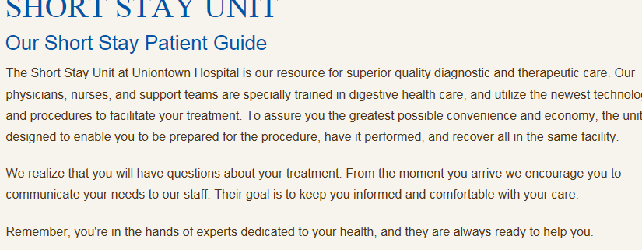

Intro:

* We like this one that we stole online
* We need this to be generic in case the patient does not stay in the unit – on opening line along the lines of “If you require an overnight stay after your procedure”…..
* Small group with lots of attention and care to your personal needs.

Areas we want to cover:

**Parking**

* Parking in geary garage - $35 max over 6 hours

**Food**

* Able to order from the room service menu **from 0700 to 1830**
* Outside of those hours, cold trays are available

**Bathroom**

* Shared bathroom in a low census, quiet area
* You will be out of bed walking in the hallway frequently. We encourage early ambulation. Make it seems like this was somewhat intentional to encourage more activity.
* EVS rounds on toilets frequently to maintain cleanliness

**Visitors**

* Visiting hours are 0800-2000
* We encourage your family to see you after the procedure but there are no overnight accommodations for guests

**Room itself**

* **We want to make the space as inviting as we can but make sure people know it is small and no window**
* **Clean, efficient**
* **Quiet**
* **Private**
* **TV – cable access, patient education (state of the art at your finger tips prescribed patient education)**
* **Music stations**
* **Regular hospital bed**
* **3:1 RN to patient ratio – CLOSE OBSERVATION**
* **Specially trained staff to aid you in a quick recovery**

**Check out process**

* **Seen by MD early in the AM – around 0800**
* **Discharge goal of 0900**
* **You will need to arrange for transport – and someone to drive/accompany you home.**
* **Please have your family member in by 0800 to hear all discharge instructions to help aid you in your recovery at home.**
* **Share with your RN your preferred pharmacy so that prescriptions can be sent over for you**
* **Efficient discharge process to ensure your continued recovery at home.**

**We like this from Stanford as well for the intro or closing…..**

